1. When making a dilution of Euglena culture, what type of water do you use?
a. deionized water
b. distilled water
c. tap water
*d. spring water
e. salt water

2. Which graph is an absorbance spectrum?
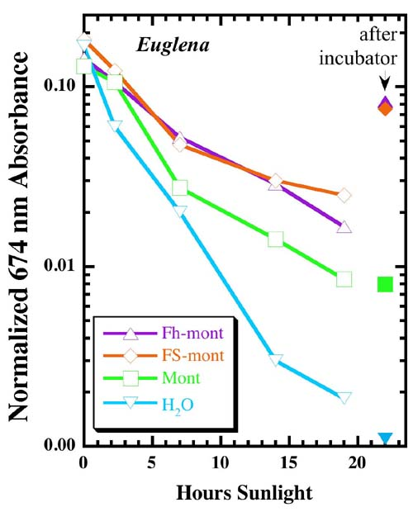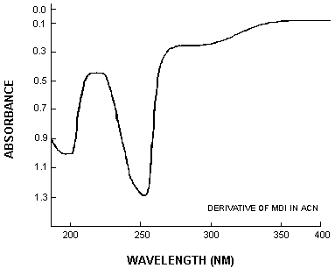
Graph A Graph B

a. Graph A
*b. Graph B

3. Based on this absorbance spectrum, what is the wavelength of maximum
absorbance for chlorophyll b?
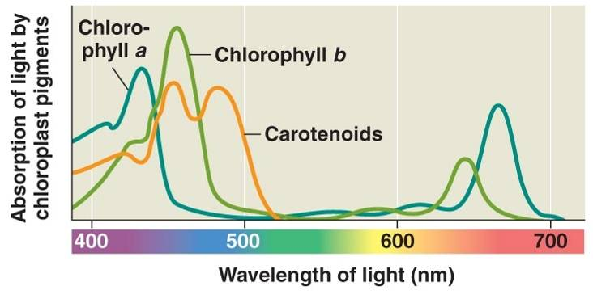

a. 427 nm
b. 440 nm
*c. 455 nm
d. 485 nm
e. 667 nm

4. In an original population of Euglena, the density is 1,000 cells/mL. If one dilutes
the original culture by a dilution factor of 2, and you do three dilutions, how many
cells/mL are present in the final dilution?

a. 1,000 cells/mL
b. 500 cells/mL
c. 250 cells/mL
*d. 125 cells/mL
e. 68 cells/mL

